**Practical-6**

Date: - -

**AIM: Understand & identify Packet(L3) & frame(L2) content detail.**

Tools required:

1. Desktop Computer
2. Cisco Packet Tracer

**Note:** While applying IP address, student need to allocate IP address as per his/her student ID. For Example, if student ID is 20ce005 then IP address allocation for first network should start with 5.0.0.0. For subsequent network, it should start with ID+1 i.e. 6.0.0.0, 7.0.0.0. and so on.

**Submission**: After writing answer into this word document, Student need to change name to his ID followed by practical number. Ex 20ce005_Pr1.docx. Upload on assignment segment.

**Rubrics**: Nicely drafted document with clarity in answers leads to full marks. Otherwise, submission carries proportional mark.

copy-past from cisco packet tracker is permitted.

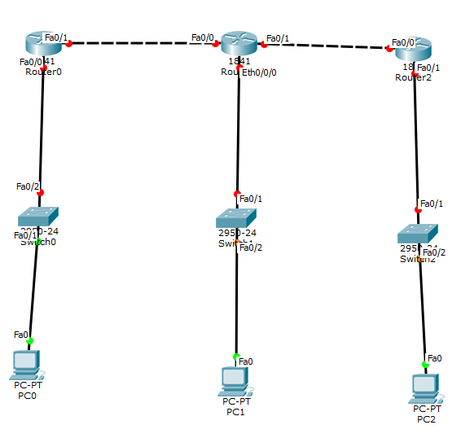

Topology for the consideration

<<Student Topology with IP address and MAC address as label>>

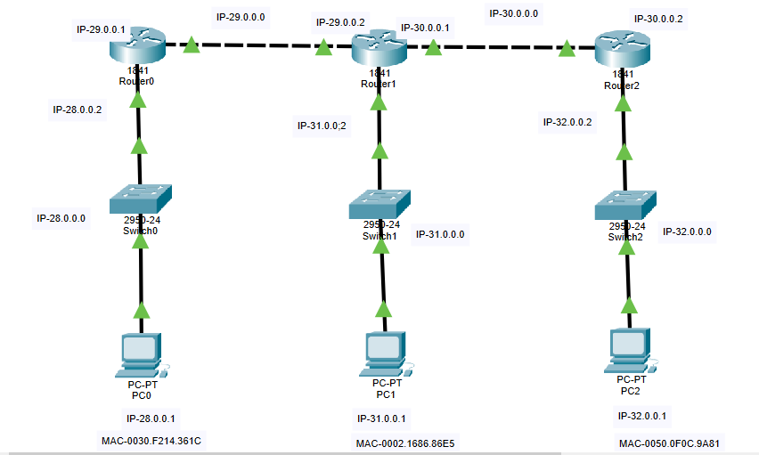

**Steps:**

1. Create topology in Realtime mode
2. Configure IP address
3. Configure Static Routing in Each routers
4. Ping from PC0 to rest other PCs and all interface of routers and fill success table
5. Go to Simulation mode
6. Prepare MAC and IP address Table.
7. Prepare ARP table for all PCs
8. Prepare Routing tables for Router0, Router1 and Router2
9. Prepare ARP tables for Router0, Router1 and Router2
10. Prepare MAC table of all switches
11. In simulation mode follow instruction as given in exercise and write answer of questions.

**PC0**

|  |  |  |  |
| --- | --- | --- | --- |
| **Destination machine** | **Destination IP address** | **Command** | **Success/Fail** |
| FE0/0 of Router0 | 28.0.0.2 | Ping 28.0.0.2 | Success |
| FE0/1 of Router0 | 29.0.0.1 | Ping 29.0.0.1 | Success |
| FE0/0 of Router1 | 29.0.0.2 | Ping 29.0.0.2 | Success |
| FE0/1 of Router1 | 30.0.0.1 | Ping 30.0.0.1 | Success |
| FE0/0/0 of Router1 | 31.0.0.2 | Ping 31.0.0.2 | Success |
| PC1 | 31.0.0.1 | Ping 31.0.0.1 | Success |
| FE0/0 of Router2 | 30.0.0.2 | Ping 30.0.0.2 | Success |
| FE0/1 of Router2 | 32.0.0.2 | Ping 32.0.0.2 | Success |
| PC2 | 32.0.0.1 | Ping 32.0.0.1 | Success |

Ping Success table

|  |  |  |
| --- | --- | --- |
| **Computer/Router Interface** | **MAC address** | **IP address** |
| PC0 | 0030.F214.361C | 28.0.0.1 |
| Router0 FE0/0 | 0001.6366.A101 | 28.0.0.2 |
| Router0 FE0/1 | 0001.6366.A102 | 29.0.0.1 |
| Router1 FE0/0 | 00D0.FFAA.DA01 | 29.0.0.2 |
| Router1 FE0/1 | 00D0.FFAA.DA02 | 30.0.0.1 |
| Router1 ETH0/0/0 | 0090.2150.7B98 | 31.0.0.2 |
| PC1 | 0002.1686.86E5 | 31.0.0.1 |
| Router2 FE0/0 | 0000.0C50.3001 | 30.0.0.2 |
| Router2 FE0/1 | 0000.0C50.3002 | 32.0.0.2 |
| PC2 | 0050.0F0C.9A81 | 32.0.0.1 |

MAC and IP address Table

|  |  |  |
| --- | --- | --- |
| **MAC Address** | **IP Address** | **Interface** |
| 0001.6366.A101 | 28.0.0.2 | FastEthernet0 |

ARP Table for PC0

|  |  |  |
| --- | --- | --- |
| **MAC Address** | **IP Address** | **Interface** |
| 0090.2150.7B98 | 31.0.0.2 | FastEthernet0 |

ARP Table for PC1

|  |  |  |
| --- | --- | --- |
| **MAC Address** | **IP Address** | **Interface** |
| 0000.0C50.3002 | 32.0.0.2 | FastEthernet0 |

ARP Table for PC2

|  |  |  |  |  |
| --- | --- | --- | --- | --- |
| **Type** | **Network** | **Port** | **Next Hop ID** | **Metric** |
| C | 28.0.0.0/8 | FastEthernet0/0 | --- | 0/0 |
| C | 29.0.0.0/8 | FastEthernet0/1 | --- | 0/0 |
| R | 30.0.0.0/8 | FastEthernet0/1 | 29.0.0.2 | 120/1 |
| R | 31.0.0.0/8 | FastEthernet0/1 | 29.0.0.2 | 120/1 |
| R | 32.0.0.0/8 | FastEthernet0/1 | 29.0.0.2 | 120/2 |

Routing table for Router0

|  |  |  |  |  |
| --- | --- | --- | --- | --- |
| **Type** | **Network** | **Port** | **Next Hop ID** | **Metric** |
| R | 28.0.0.0/8 | FastEthernet0/0 | 29.0.0.1 | 120/1 |
| C | 29.0.0.0/8 | FastEthernet0/0 | --- | 0/0 |
| C | 30.0.0.0/8 | FastEthernet0/1 | --- | 0/0 |
| C | 31.0.0.0/8 | Ethernet0/0/0 | --- | 0/0 |
| R | 32.0.0.0/8 | FastEthernet0/1 | 30.0.0.2 | 120/1 |

Routing table for Router1

|  |  |  |  |  |
| --- | --- | --- | --- | --- |
| **Type** | **Network** | **Port** | **Next Hop ID** | **Metric** |
| R | 28.0.0.0/8 | FastEthernet0/0 | 30.0.0.1 | 120/2 |
| R | 29.0.0.0/8 | FastEthernet0/0 | 30.0.0.1 | 120/1 |
| C | 30.0.0.0/8 | FastEthernet0/0 | --- | 0/0 |
| R | 31.0.0.0/8 | FastEthernet0/0 | 30.0.0.1 | 120/1 |
| C | 32.0.0.0/8 | FastEthernet0/1 | --- | 0/0 |

Routing table for Router2

|  |  |  |
| --- | --- | --- |
| **IP Address** | **MAC Address** | **Interface** |
| 28.0.0.1 | 0030.F214.361C | FastEthernet0/0 |
| 28.0.0.2 | 0001.6366.A101 | FastEthernet0/0 |
| 29.0.0.1 | 0001.6366.A102 | FastEthernet0/1 |
| 29.0.0.2 | 00D0.FFAA.DA01 | FastEthernet0/1 |

ARP Table for Router0

|  |  |  |
| --- | --- | --- |
| **IP Address** | **MAC Address** | **Interface** |
| 29.0.0.1 | 0001.6366.A102 | FastEthernet0/0 |
| 29.0.0.2 | 00D0.FFAA.DA01 | FastEthernet0/0 |
| 30.0.0.1 | 00D0.FFAA.DA02 | FastEthernet0/1 |
| 30.0.0.2 | 0000.0C50.3001 | FastEthernet0/1 |
| 31.0.0.1 | 0090.2150.7B98 | Ethernet0/0/0 |
| 31.0.0.2 | 0002.1686.86E5 | Ethernet0/0/0 |

ARP Table for Router1

|  |  |  |
| --- | --- | --- |
| **IP Address** | **MAC Address** | **Interface** |
| 30.0.0.1 | 00D0.FFAA.DA02 | FastEthernet0/0 |
| 30.0.0.2 | 0000.0C50.3001 | FastEthernet0/0 |
| 32.0.0.1 | 0000.0C50.3002 | FastEthernet0/1 |
| 32.0.0.2 | 0050.0F0C.9A81 | FastEthernet0/1 |

ARP Table for Router2

|  |  |  |
| --- | --- | --- |
| **VLAN ID** | **MAC Address** | **port** |
| 1 | 0001.6366.A101 | FastEthernet0/1 |
| 1 | 0030.F214.361C | FastEthernet0/2 |

Switching table for Switch0

|  |  |  |
| --- | --- | --- |
| **VLAN ID** | **MAC Address** | **port** |
| 1 | 0090.2150.7B98 | FastEthernet0/2 |
| 1 | 0002.1686.86E5 | FastEthernet0/1 |

Switching table for Switch1

|  |  |  |
| --- | --- | --- |
| **VLAN ID** | **MAC Address** | **port** |
| 1 | 0050.0F0C.9A81 | FastEthernet0/1 |
| 1 | 0000.0C50.3002 | FastEthernet0/2 |

Switching table for Switch2

**In simulation mode**

**Exercise-1**: Ping form PC0 to FE0/0 of Router0

click on capture forward once so packet goes to switch, Inspect& write Inbound and Outbound PDU and fill following table

|  |  |  |
| --- | --- | --- |
|  | **In Bound** | **Out Bound** |
| Source MAC Address | 0030.F214.361C | 0030.F214.361C |
| Destination MAC address | 0001.6366.A101 | 0001.6366.A101 |
| Source IP Address | 28.0.0.1 | 28.0.0.1 |
| Destination IP address | 28.0.0.2 | 28.0.0.2 |

Question: What decision will be taken by switch?

Answer: When the data packets sent from PC0 will reach to switch then it will look for sender’s and receiver’s MAC addresses and on the basis of that switch will take decision that how to control traffic on witch link it should pass the data traffic , if the associated MAC address will not found then it will return the data packets.

**Exercise-2**: Ping form PC0 to FE0/1 of Router0

Click on capture forward once so packet goes to switch, Inspect& write Inbound and Outbound PDU and fill following table

|  |  |  |
| --- | --- | --- |
|  | **In Bound** | **Out Bound** |
| Source MAC Address | 0030.F214.361C | 0030.F214.361C |
| Destination MAC address | 0001.6366.A101 | 0001.6366.A101 |
| Source IP Address | 28.0.0.1 | 28.0.0.1 |
| Destination IP address | 29.0.0.1 | 29.0.0.1 |

Question: Is there any difference between table content of exercise-1 and 2? Why?

Answer: Yes, the destination IP address is different but the all other things are same as table content of exercise-1. It is happing because we wanted to ping from “PC0 to FE0/1” and that is why the network in which our data packets wants to go is different than previous one that is why MAC address is same but because of that different network the IP address of destination is different.

**Exercise-3**: Ping form PC0 to FE0/0 of Router1

Click on capture forward once so packet goes to switch, Inspect & write Inbound and Outbound PDU and fill following table

|  |  |  |
| --- | --- | --- |
|  | **In Bound** | **Out Bound** |
| Source MAC Address | 0030.F214.361C | 0030.F214.361C |
| Destination MAC address | 0001.6366.A101 | 0001.6366.A101 |
| Source IP Address | 28.0.0.1 | 28.0.0.1 |
| Destination IP address | 29.0.0.2 | 29.0.0.2 |

Click on capture forward once so packet goes to Router0, Inspect & write Inbound and Outbound PDU and fill following table

|  |  |  |
| --- | --- | --- |
|  | **In Bound** | **Out Bound** |
| Source MAC Address | 0030.F214.361C | 0001.6366.A102 |
| Destination MAC address | 0001.6366.A101 | 00D0.FFAA.DA01 |
| Source IP Address | 28.0.0.1 | 28.0.0.1 |
| Destination IP address | 29.0.0.2 | 29.0.0.2 |

**Question: What decision will be taken by Router0?**

**Answer:** As the routers are layer 3 device, every router will look sender’s and receiver’s IP address and on the basis of that it will take decision that how to route the data packets. Then it will accordingly route the data packets on respected link.

**Question:** **Is Inbound and outbound PDU detail remain same? If not why**?

**Answer:** No, the Inbound and outbound PDU details will not remain same. In this case we want to

communicate with different type of network. (i.e. In this case From 28.0.0.0 to 32.0.0.0) so,

"Router will route the packets" means that Router-0 will append sender's and receiver's address in

header because now the data packets will be going to different network so, PDU details will be

change accordingly by router to route the packets via link.

**Exercise-4**: Ping form PC0 to PC1 (For even roll number of student PC0 to PC2)

Click on capture forward so packet goes to switch0, Inspect & write Inbound and Outbound PDU and fill following table

|  |  |  |
| --- | --- | --- |
|  | **In Bound** | **Out Bound** |
| Source MAC Address | 0030.F214.361C | 0030.F214.361C |
| Destination MAC address | 0001.6366.A101 | 0001.6366.A101 |
| Source IP Address | 28.0.0.1 | 28.0.0.1 |
| Destination IP address | 32.0.0.1 | 32.0.0.1 |

Click on capture forward so packet goes to Router0, Inspect & write Inbound and Outbound PDU and fill following table

|  |  |  |
| --- | --- | --- |
|  | **In Bound** | **Out Bound** |
| Source MAC Address | 0030.F214.361C | 0001.6366.A102 |
| Destination MAC address | 0001.6366.A101 | 00D0.FFAA.DA01 |
| Source IP Address | 28.0.0.1 | 28.0.0.1 |
| Destination IP address | 32.0.0.1 | 32.0.0.1 |

Click on capture forward so packet goes to Router1, Inspect & write Inbound and Outbound PDU and fill following table

|  |  |  |
| --- | --- | --- |
|  | **In Bound** | **Out Bound** |
| Source MAC Address | 0001.6366.A102 | 00D0.FFAA.DA02 |
| Destination MAC address | 00D0.FFAA.DA01 | 0000.0C50.3001 |
| Source IP Address | 28.0.0.1 | 28.0.0.1 |
| Destination IP address | 32.0.0.1 | 32.0.0.1 |

Click on capture forward so packet goes to Router2, Inspect & write Inbound and Outbound PDU and fill following table

|  |  |  |
| --- | --- | --- |
|  | **In Bound** | **Out Bound** |
| Source MAC Address | 00D0.FFAA.DA02 | 0000.0C50.3002 |
| Destination MAC address | 0000.0C50.3001 | 0050.0F0C.9A81 |
| Source IP Address | 28.0.0.1 | 28.0.0.1 |
| Destination IP address | 32.0.0.1 | 32.0.0.1 |

Click on capture forward so packet goes to switch2, Inspect & write Inbound and Outbound PDU and fill following table

|  |  |  |
| --- | --- | --- |
|  | **In Bound** | **Out Bound** |
| Source MAC Address | 0000.0C50.3002 | 0000.0C50.3002 |
| Destination MAC address | 0050.0F0C.9A81 | 0050.0F0C.9A81 |
| Source IP Address | 28.0.0.1 | 28.0.0.1 |
| Destination IP address | 32.0.0.1 | 32.0.0.1 |

Click on capture forward so packet goes to PC2, Inspect & write Inbound and Outbound PDU and fill following table

|  |  |  |
| --- | --- | --- |
|  | **In Bound** | **Out Bound** |
| Source MAC Address | 0000.0C50.3002 | 0050.0F0C.9A81 |
| Destination MAC address | 0050.0F0C.9A81 | 0000.0C50.3002 |
| Source IP Address | 28.0.0.1 | 28.0.0.1 |
| Destination IP address | 32.0.0.1 | 32.0.0.1 |

Click on capture forward so packet goes to switch2, Inspect & write Inbound and Outbound PDU and fill following table

|  |  |  |
| --- | --- | --- |
|  | **In Bound** | **Out Bound** |
| Source MAC Address | 0050.0F0C.9A81 | 0050.0F0C.9A81 |
| Destination MAC address | 0000.0C50.3002 | 0000.0C50.3002 |
| Source IP Address | 32.0.0.1 | 32.0.0.1 |
| Destination IP address | 28.0.0.1 | 28.0.0.1 |

Click on capture forward so packet goes to Router2, Inspect & write Inbound and Outbound PDU and fill following table

|  |  |  |
| --- | --- | --- |
|  | **In Bound** | **Out Bound** |
| Source MAC Address | 0050.0F0C.9A81 | 0000.0C50.3001 |
| Destination MAC address | 0000.0C50.3002 | 00D0.FFAA.DA02 |
| Source IP Address | 32.0.0.1 | 32.0.0.1 |
| Destination IP address | 28.0.0.1 | 28.0.0.1 |

Click on capture forward so packet goes to Router1, Inspect & write Inbound and Outbound PDU and fill following table

|  |  |  |
| --- | --- | --- |
|  | **In Bound** | **Out Bound** |
| Source MAC Address | 0000.0C50.3001 | 00D0.FFAA.DA01 |
| Destination MAC address | 00D0.FFAA.DA02 | 0001.6366.A102 |
| Source IP Address | 32.0.0.1 | 32.0.0.1 |
| Destination IP address | 28.0.0.1 | 28.0.0.1 |

Click on capture forward so packet goes to Router0, Inspect & write Inbound and Outbound PDU and fill following table

|  |  |  |
| --- | --- | --- |
|  | **In Bound** | **Out Bound** |
| Source MAC Address | 00D0.FFAA.DA01 | 0001.6366.A101 |
| Destination MAC address | 0001.6366.A102 | 0030.F214.361C |
| Source IP Address | 32.0.0.1 | 32.0.0.1 |
| Destination IP address | 28.0.0.1 | 28.0.0.1 |

Click on capture forward so packet goes to switch0, Inspect & write Inbound and Outbound PDU and fill following table

|  |  |  |
| --- | --- | --- |
|  | **In Bound** | **Out Bound** |
| Source MAC Address | 0001.6366.A101 | 0001.6366.A101 |
| Destination MAC address | 0030.F214.361C | 0030.F214.361C |
| Source IP Address | 32.0.0.1 | 32.0.0.1 |
| Destination IP address | 28.0.0.1 | 28.0.0.1 |

Click on capture forward so packet goes to PC0, Inspect & write Inbound and Outbound PDU and fill following table

|  |  |  |
| --- | --- | --- |
|  | **In Bound** | **Out Bound** |
| Source MAC Address | 0001.6366.A101 | --- |
| Destination MAC address | 0030.F214.361C | --- |
| Source IP Address | 32.0.0.1 | --- |
| Destination IP address | 28.0.0.1 | --- |

Observe/inspect values of above tables and answer following questions.

**Question: Is Source IP and Destination IP remains same for one way of data transmission?**

**Answer:** Yes, the source IP address and destination IP address for one way of data transmission will remain same. Because at the end we want to reach from one node to another node in one way transmission.

**Justify: In reverse direction, source IP and destination IP address gets changed.**

**Answer:** Yes, in reverse direction, source IP address and destination IP address will gets changed. Because in reverse transmission we want to give assurity to sender that all data packets has arrived successfully and receiver's side this thing is called "Back-message". One can assure the data transmission using "Back-message” which is very important so, for achieving “Back-message” the reverse transmission is needed and that is why source IP address and Destination IP address will gets changed.